**2-D Fluid Dynamics Simulator Application**

# *User’s Guide*

**Tech Geeks**

# Presented by:

# Nagasindhu Kannekanti

# Ayman Almusalam

# Michael Chase Bonifant

# Sai Krishna Kalakonda

# Srikanth Reddy Bitla

# Prepared for:

# Principles of Software Engineering

# FALL 2015

The Main Screen:

When you first start Liquid 2D, you’re greeted with the main screen:

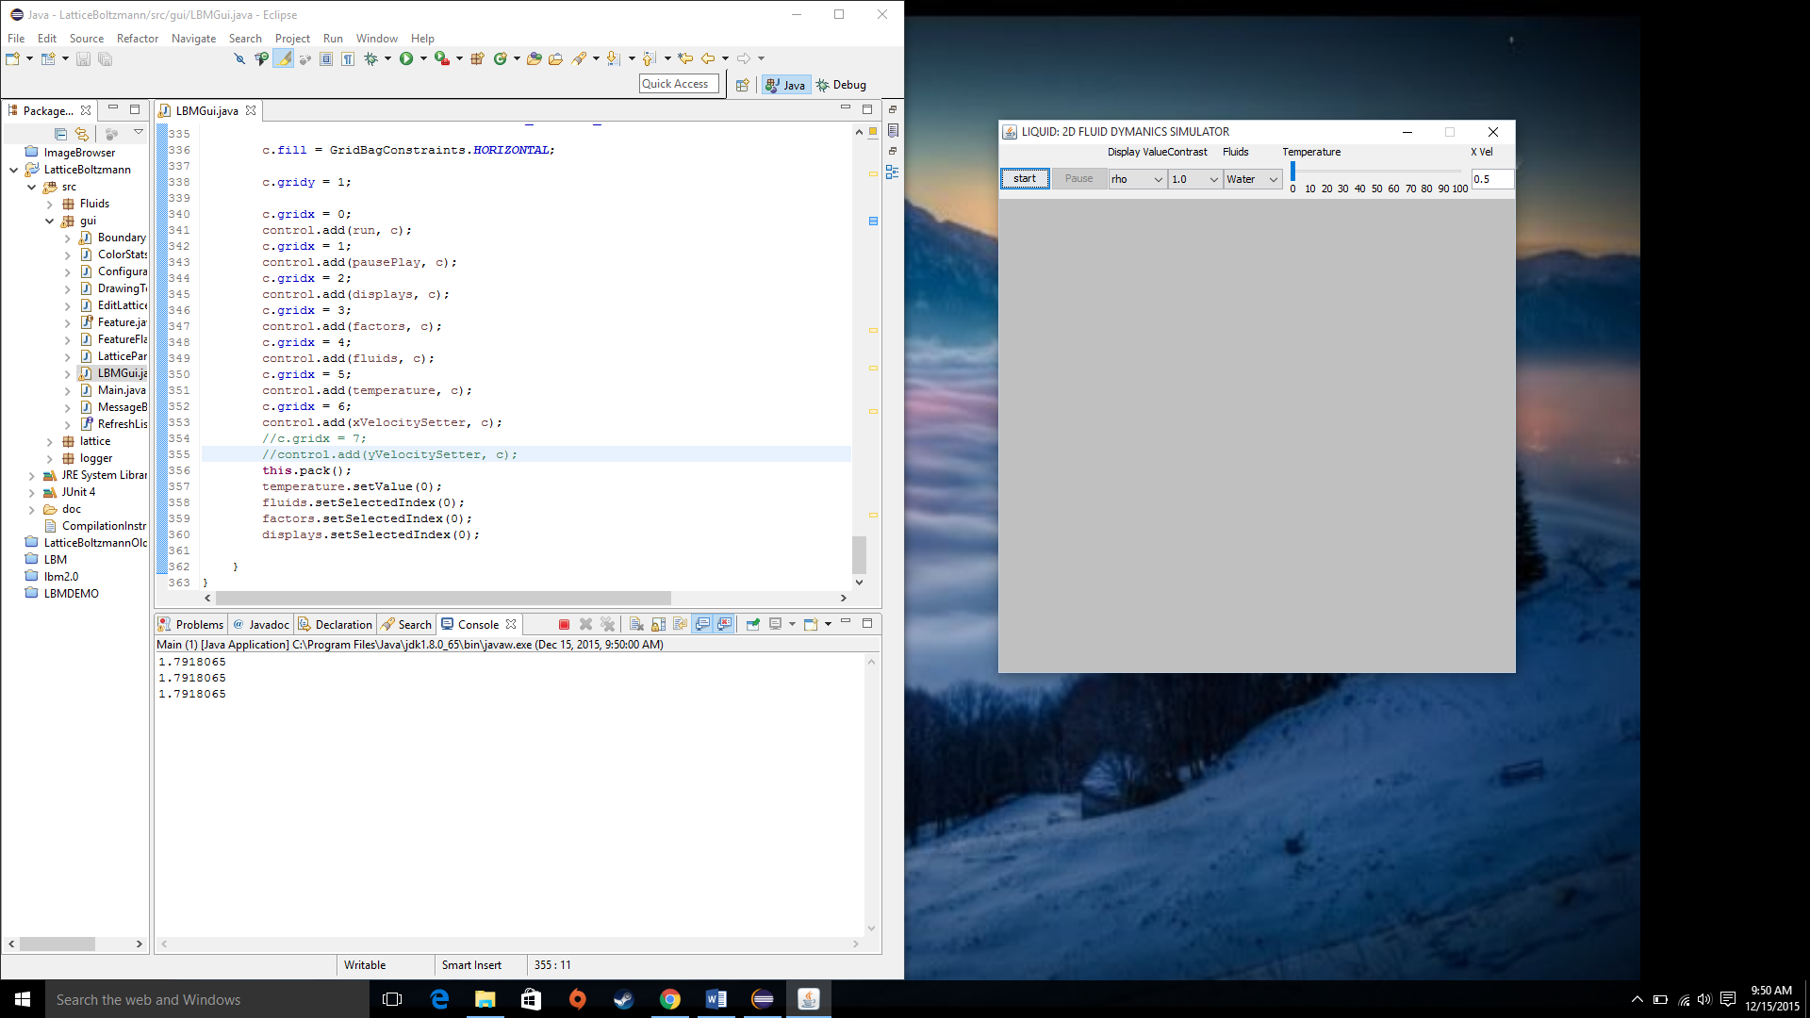

1. The Start/stop button. Clicking this switches between running a simulation and ending one.
2. The Pause/play button. Clicking this during a simulation will pause the simulation and then clicking it again allows the simulation to continue.
3. The Display menu: This lets you switch between different views of the simulation. The default is rho, which display’s ρ the density of the fluid at every spot in the simulation. Other options include, the speed of the fluid, its x & y velocities, and the curl of the fluid’s velocity.
4. The Contrast menu: This lets you boost the contrast in the display. The default value is 1, but you can increase it by powers of 2 up to 4096.
5. The Fluid Menu: This lets you select a fluid to simulate, the options are water and glycerin.
6. The Temperature Slider: This lets you change the temperature of the liquid, which in turn changes the viscosity (higher temperatures means lower viscosity, means faster more dynamic fluids). Water can set to 1C, 10C, 20C, 30C… 90C, or 99C. Similarly Glycerin can be set to 20C, 30C, 40C, … 270C.
7. X velocity: you can enter a value as the default inflowing x velocity (how fast the fluid enters from the left traveling horizontally)

Drawing Area:

Below the menu is the drawing area, which displays the configuration of the simulation before you run it. By default the entire grey area is fluid. You can immediately start drawing walls/obstructions by simply clicking and dragging in the area.

Wall display as magenta colored areas (If you hover you mouse over an obstacle it’ll display the size of the obstacle and its type)

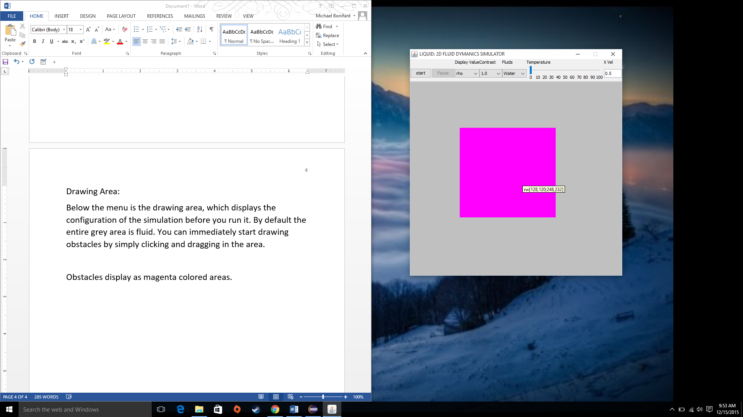

There are 3 additional Features you can add: Sources (display in red), Sinks (display in blue), or Fluid (displays in green)

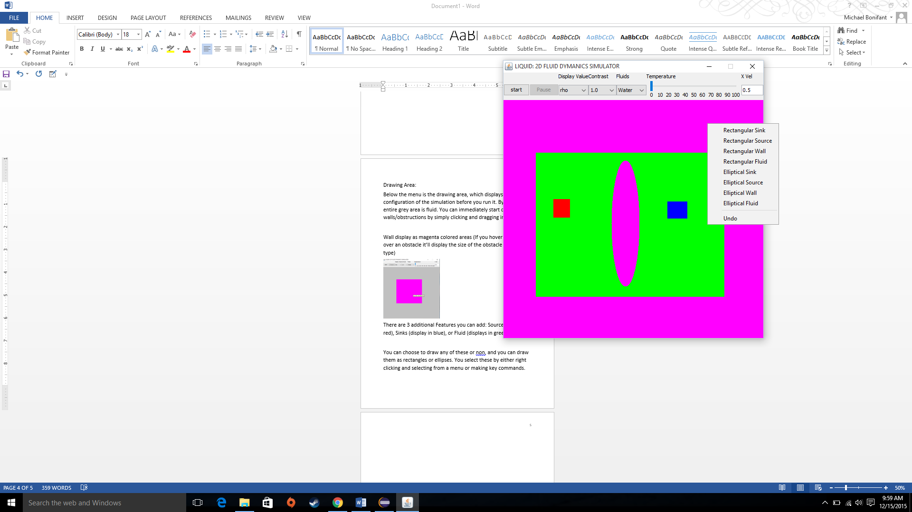

You can choose to draw any of these or none to add to the simulation and you can draw them as rectangles or ellipses. You select these by either right clicking in the drawing area and selecting from a menu or making key commands.

The key commands are : e, r, w, f, i, o, and c. e and r switch between drawing ellipses and rectangles. w is for walls, f is for fluid, i is for sources (in flows), o is for sinks (out flows), and c is for clear (emptying the screen).

Running a simulation:

Once you have your simulation ready, you can start it simply by clicking start.

For instance: this could be a simulation you might make.

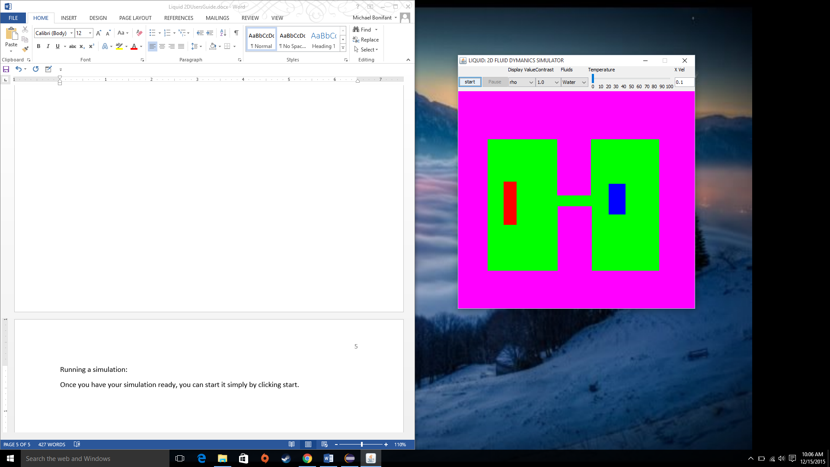

And once you click run, this would be the immediate start.

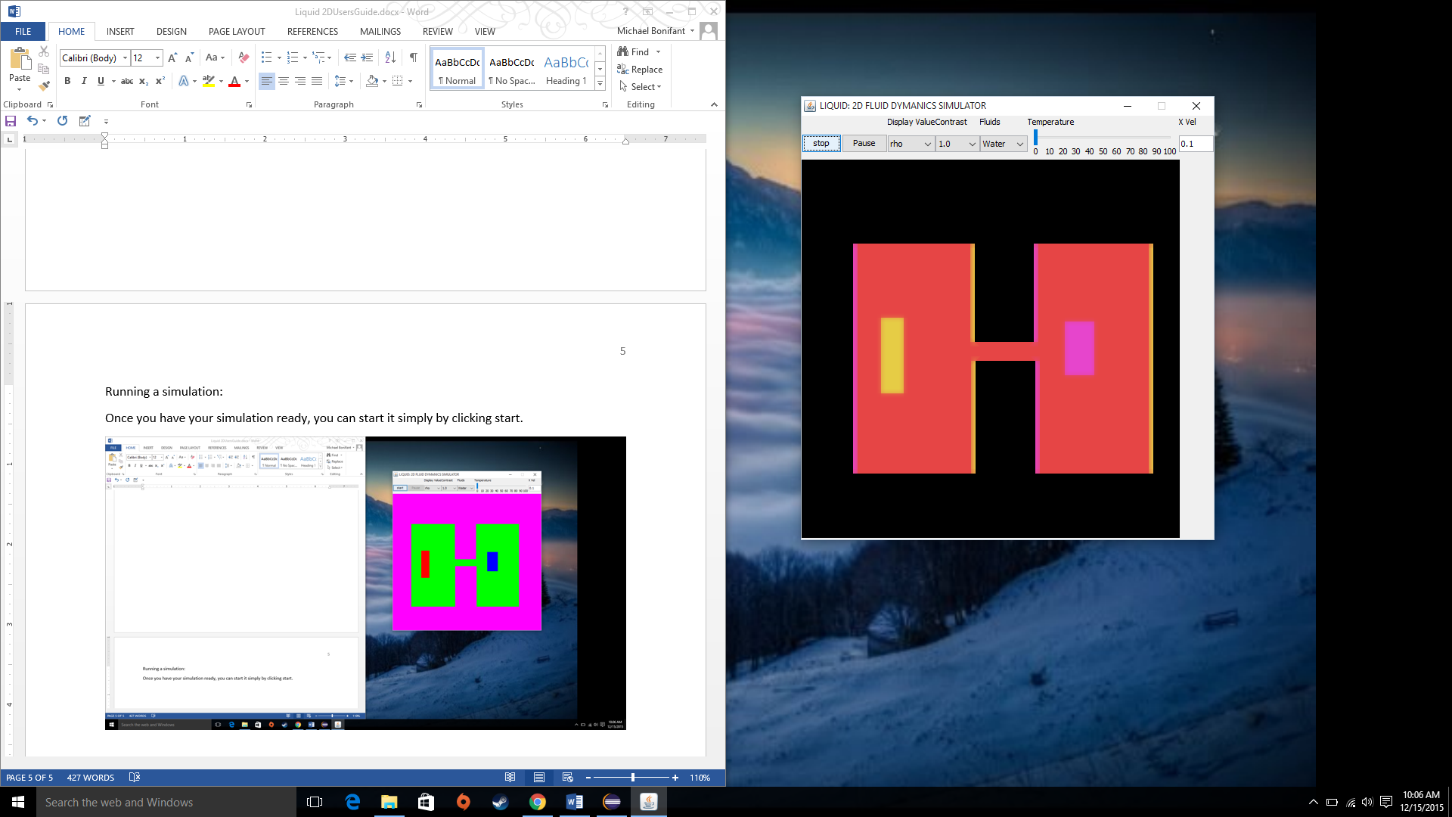

You can still change the fluid type and temperature, and the incoming x velocity.

Additional, on the main screen if you hover you mouse, it will display the fluid density (rho) at a given spot and the velocity (u).

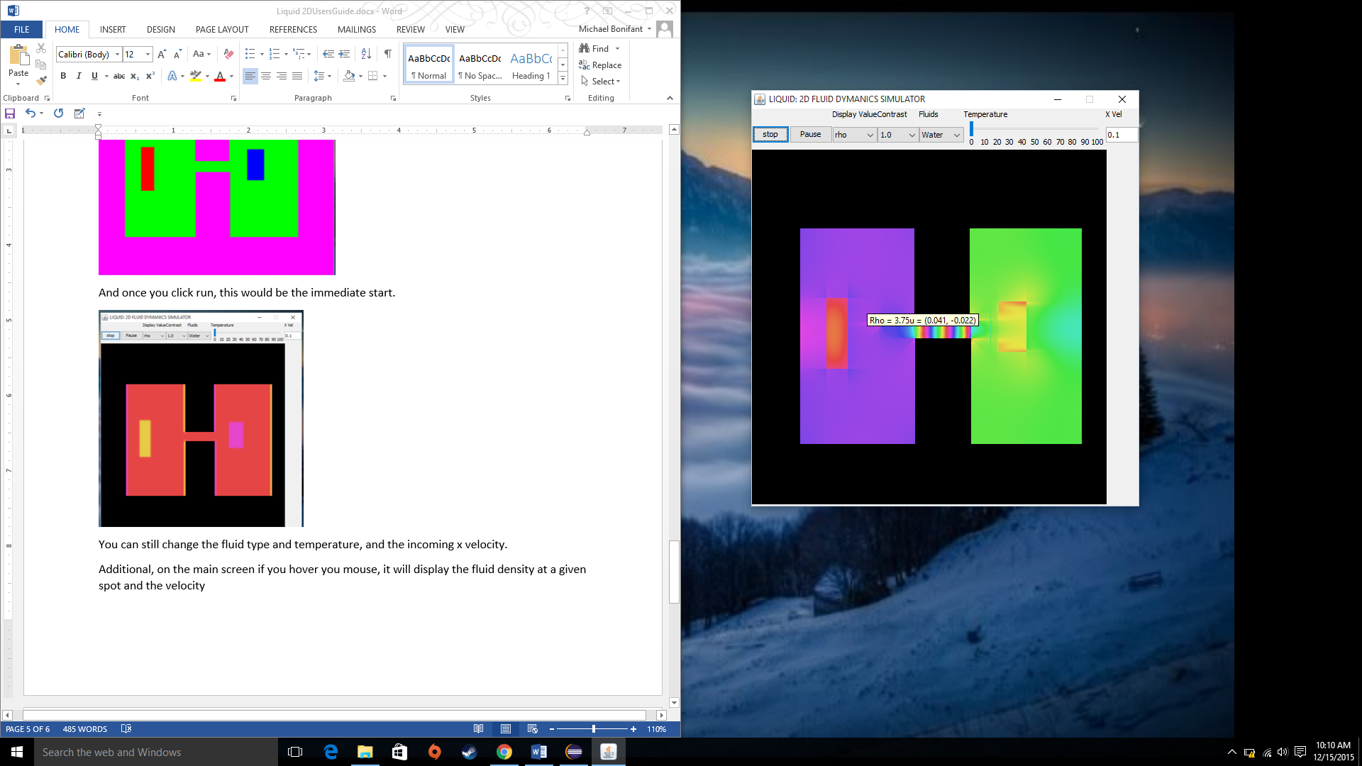

Additionally you can still draw in the simulation. However, you’re now limited to only adding walls, and the tool works like a pen now adding a wall wherever you click, or drag the mouse while pressed. For instance you could draw this barrier between the tunnel from the source,

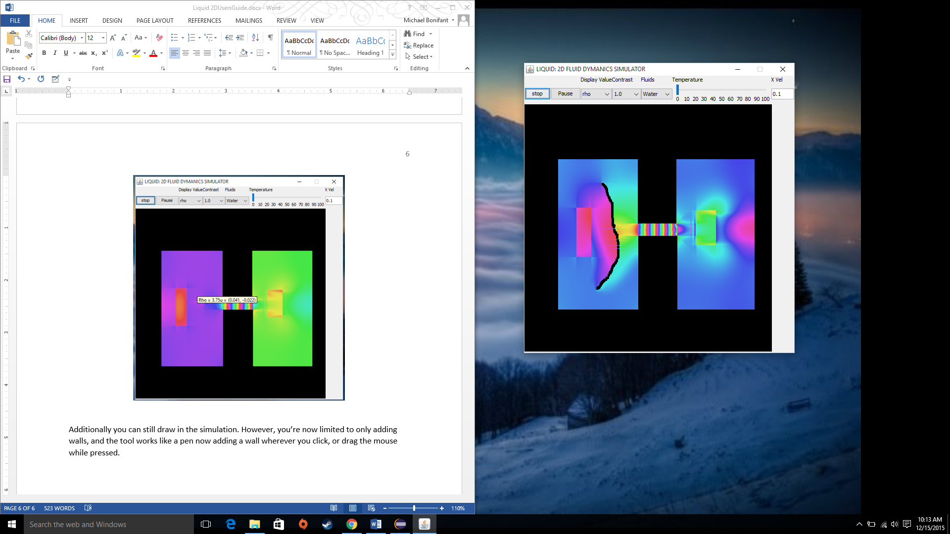

Or even cut the source and sink off entirely.

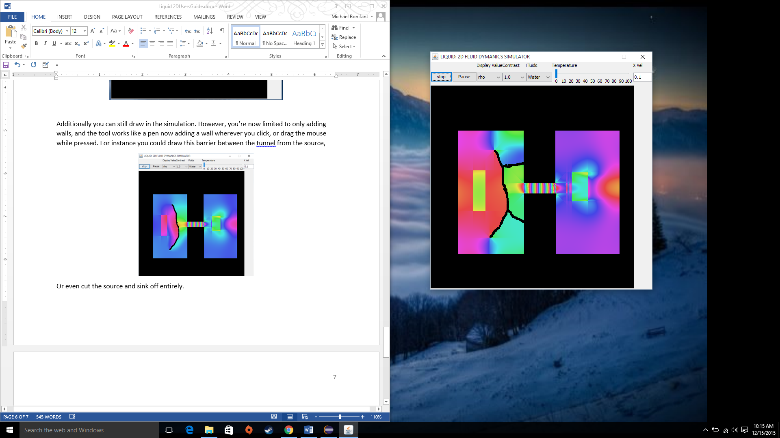

Or trap the fluid in the tunnel.

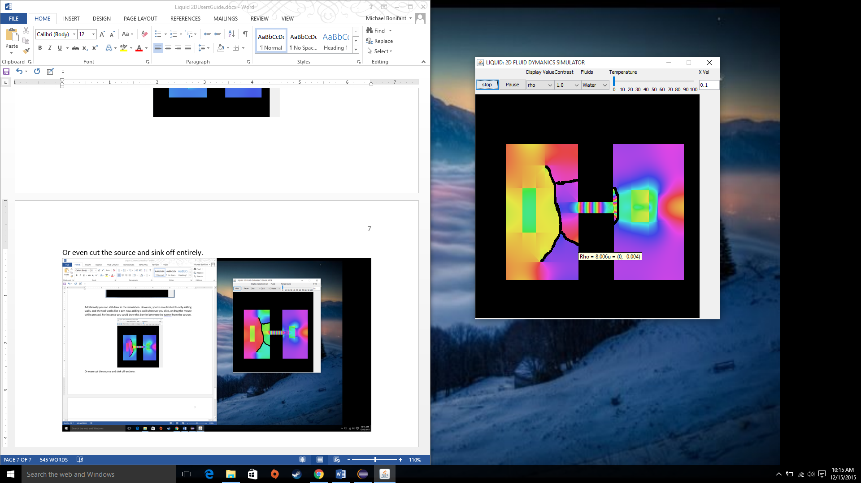

When you stop the simulation the additional drawn on walls will be removed (pausing they’ll persist, you can even add more of these drawn on barriers while paused, so it’s as if the entire wall has instantly appeared).